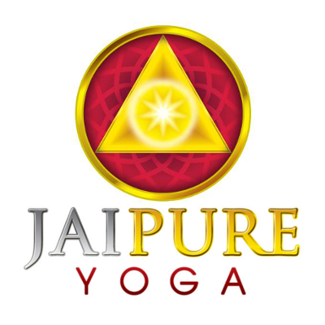
575 Bloomfield Avenue
Montclair, NJ 07042
973-744-7873
www.jaipureyoga.com

JaiPure Yoga™ Teacher Training Application

Full Name: _________________________________________________________________

Mailing Address: __________________________________________________________

Email Address:___________________________________________ Phone:___________________________

- How long have you practiced yoga?

- How many times each week?

- Do you have an home practice and what does it consist of ?

- List the specific yoga styles that you practice

- Identify the teachers you with whom you have studied

- Identify the teachers that you regularly and consistently study with?

- Do you have a meditation practice?

a. How often do you meditate each week?

b. How long do you meditate for during each session?

c. What type of meditation do you do?

- Do you participate in spiritual study of anykind?

- Please describe your study practices

- Do you have a spiritual teacher that you study with and if so, please

Identify that teacher

4. Please identify any particular precepts you believe are found in all organized religions and spiritual teachings?

5. List any other yoga-related workshops, retreats or trainings completed

6. Do you currently teach yoga or have you ever taught yoga?

7. Have you ever taught any fitness technique?

- What type of fitness technique?

- Where?

- For how long?

- Are you certified?

8. Are you vegetarian or vegan?

- If not, would you consider it for a specific period of time?

- If yes, for how long?

9. Have you studied any bodywork technique?

- Are you certified in a particular modality?

- What modality?

- For how long?

- What are the benefits of this modality?

- Is it adaptable to yoga teaching and how?

- Are you interested in studying a particular modality and what is it?

10. How did you learn about JaiPure Yoga’s Teacher Training?

11. What do you hope to gain by committing to JaiPure Yoga’s Teacher Training?

Are you committed to full participation in the program ____ Yes ____No
(List concerns or special circumstances)

I hereby acknowledge and commit to full participation in the Teacher Training at JaiPure. If accepted into the program, I hereby agree and understand that Certification is based upon full and complete participation at all training sessions.

Signed: ______________________________________________ Date: _______________________________

Please return the completed application by email (lpriggiola@gmail.com) (marcie.wallace@gmail.com) or by mail to JaiPure Yoga, 575 Bloomfield Avenue, Montclair, NJ 07042

